ROS TUTORIAL

INTRODUCTION: ROS stands for Robot Operating System. It is an open-source software framework for robotics. ROS provides a common platform for developing robot software, making it easier for researchers and developers to share code and collaborate on projects. ROS is used by a wide range of organizations, from academic research labs to industrial companies.
ROS is a set of software libraries and tools that help you build robot applications. From drivers to state-of-the-art algorithms, and with powerful developer tools, ROS has what you need for your next robotics project. And it's all open source.
Here are some of the benefits of using ROS:
- Open source: ROS is free and open source software, which means that it is available to everyone to use and modify. This makes it a great platform for collaboration and innovation.
- Cross-platform: ROS can be used on a variety of platforms, including Linux, macOS, and Windows. This makes it a great choice for developing robots that need to be portable.
- Modular: ROS is a modular framework, which means that it is easy to add new features and functionality. This makes it a great choice for developing complex robots with a wide range of capabilities.
- Active community: ROS has a large and active community of users and developers. This means that there is always help available if you need it.
If you are interested in developing robots, ROS is a great place to start. It is a powerful and flexible platform that can be used to build a wide variety of robots.

Prerequisites: To make the most of this tutorial, it is recommended that you have basic knowledge of ROS, including installing ROS on your system. If you are new to ROS, you can refer to the ROS documentation (link provided in the resources section) for installation instructions and beginner-level tutorials.

QUICK-START: Here are the steps on how to get started with ROS:
Choose a platform. ROS can be installed on a variety of platforms, including Linux, macOS, and Windows. The official ROS website has installation instructions for each platform.

Install ROS. Once you have chosen a platform, you can install ROS. The installation process is different for each platform, so be sure to follow the instructions carefully.

Setting up the environment: If you just installed ROS from apt on Ubuntu then you will have to source the setup.*sh files by running the following line of command in the terminal:

source /opt/ros/noetic/setup.bash

Create a ROS workspace. A ROS workspace is a directory that contains all of your ROS projects. To create a ROS workspace, run the following command in a terminal:

mkdir -p ~/catkin_ws/src

The above line of code creates a directory named ‘catkin_ws’ and a folder inside it named ‘src’
Now to build this directory into a catkin workspace run the following line in the command terminal:

cd ~/catkin_ws/
catkin_make

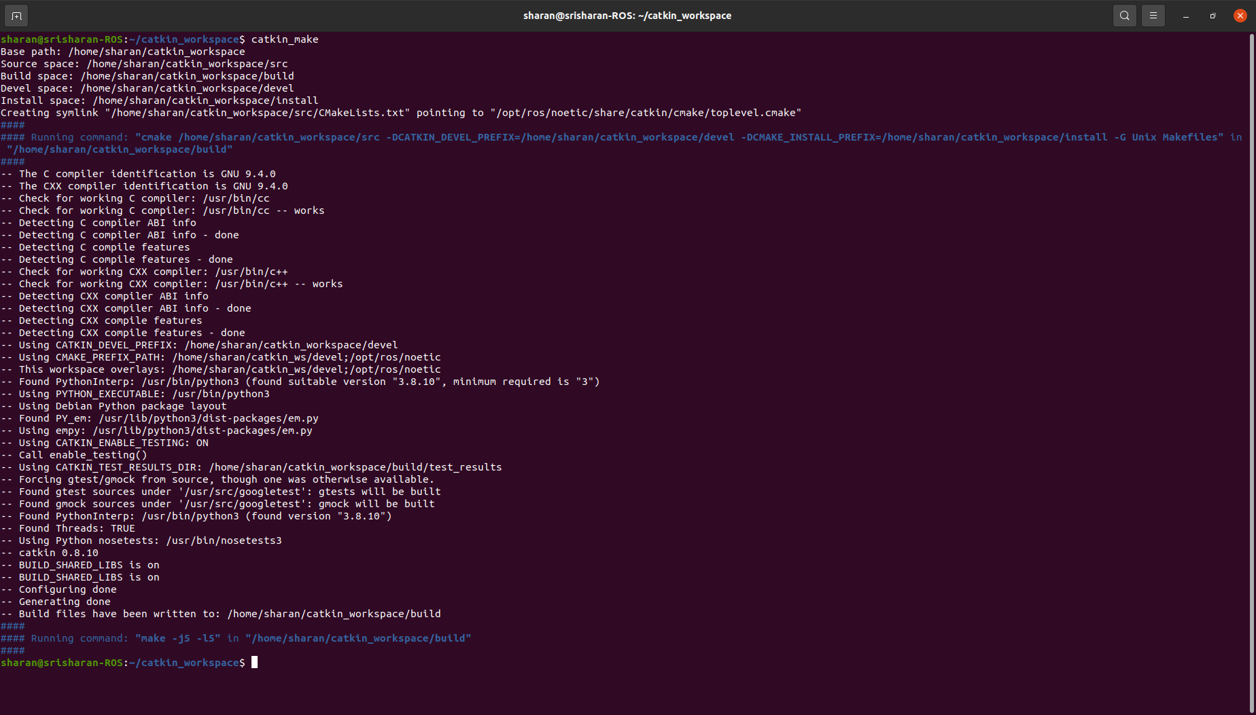
The above line of code takes you into the catkin_ws directory and executes the command catkin_make. catkin_make is a command-line tool that builds ROS packages. It is a wrapper around the CMake build system, and it takes care of all of the details of building ROS packages, such as finding dependencies and generating build files. Once you run the catkin_make command you should see something like the figure displayed on your command terminal.
Now, if you go into the catkin_ws director you will be able to see two more folders generated along with the “src” i.e. “devel” and “build”.

Setting up a ROS package: In this section, we will walk you through the process of setting up a ROS package, which will serve as the foundation for your ROS development projects. A ROS package is a directory that contains ROS-specific files and configurations. Let's get started!
Run the following command to create a new package named "beginner_package":

$ cd ~/catkin_ws/src
$ catkin_create_pkg beginner_package rospy std_msgs

The above command creates a package named "beginner_package" and includes the "rospy" dependency, which is necessary for Python-based ROS nodes. std_msgs is a ROS package that provides a set of common message types. These message types are used to represent data that is commonly used in robotics, such as geometry, time, and sensor data. Feel free to replace "beginner_package" with your desired package name. You can also add other dependencies like roscpp if you are comfortable with C++ rather than python but for this tutorial let us limit ourselves to Python based ROS nodes.

catkin_create_pkg <package_name> [depend1] [depend2] [depend3]

Once the package is created, always run the below command-line to source the package.

source /opt/ros/noetic/setup.bash

Sourcing has to be done every time you create a new package. By sourcing the workspace, you make the package and its dependencies available to the ROS environment.

Now run the catkin_make command again to build the package just like how you built the workspace.

cd ~/catkin_ws/
catkin_make

ROS Publishing and Subscribing: Before we dive into the practical implementation, let's briefly understand the concepts of publishing and subscribing in ROS. ROS follows a publish-subscribe messaging model, where nodes communicate with each other by publishing and subscribing to topics. Publishers send messages to a specific topic, and subscribers receive those messages from the same topic. This decoupled communication mechanism allows for modular and flexible robot software development.

ROS MASTER
ROS Topic
Publisher Node
Subscriber Node
ROS Message
ROS Message
Request for topic message

Creating a Publisher Node: Create a new Python script named “talker.py” inside the “src” folder of the package that you have created. This script will publish messages to a topic. Here's an example of a simple publisher node that publishes a string message:

#!/usr/bin/env python

import rospy
from std_msgs.msg import String

def talker():
pub = rospy.Publisher('chatter', String, queue_size=10)
rospy.init_node('talker', anonymous=True)
rate = rospy.Rate(10) # 10hz
while not rospy.is_shutdown():
hello_str = "hello this message is from the publisher %s" % rospy.get_time()
rospy.loginfo(hello_str)
pub.publish(hello_str)
rate.sleep()

if __name__ == '__main__':
try:
talker()
except rospy.ROSInterruptException:
pass

The first line of code is a shebang line. It tells the operating system which interpreter to use to run the script.
The next two lines import the ROS libraries rospy and std_msgs.
The function called talker() creates a publisher object, initializes a ROS node, creates a rate object, and publishes a message on the topic chatter at a rate of 10Hz.
The last 4 lines of the code, checks if the script is being run as the main script. If it is, it calls the talker() function. If the script is not being run as the main script, it does nothing.

You can use this sample code to customize your publisher node and publish anything that you desire. But the architecture of the Publisher node code remains the same.

Creating a Subscriber Node: In the same folder create another Python script named listener.py. This script will subscribe to the topic and receive the messages published by the publisher node. Here's an example of a simple subscriber node:

#!/usr/bin/env python

import rospy
from std_msgs.msg import String

def callback(data):
rospy.loginfo(rospy.get_caller_id() + 'I heard from the talker_listener%s', data.data)

def listener():

rospy.init_node('listener', anonymous=True)

rospy.Subscriber('chatter_2', String, callback)

# spin() simply keeps python from exiting until this node is stopped
rospy.spin()

if __name__ == '__main__':
listener()

The first line of code is a shebang line. It tells the operating system which interpreter to use to run the script.
The next two lines import the ROS libraries rospy and std_msgs.
The def callback(data): function is a callback function. It is called whenever a message is received on the topic "chatter_2".
The rospy.loginfo() function logs the message to the ROS log.
The listener() function initializes a ROS node, creates a subscriber object, and subscribes to the topic chatter_2.
rospy.init_node() function initializes a ROS node. The name of the node is subscriber_node.
The rospy.Subscriber() function creates a subscriber object. The subscriber object is used to subscribe to a topic. The topic name is “chatter_2”. The message type is String. The callback function is callback.
The rospy.spin() function blocks the main thread of the node and waits for messages to be received on the subscribed topics.

You can use this sample code to customize your subscriber node and publish anything that you desire. But the architecture of the Subscriber node code remains the same.

Creating a node that is both a publisher and a subscriber: In the same folder create another Python script named talker_listener.py. This script will subscribe to the topic and receive the messages published by the publisher node and also publish a message to a new topic. Here's an example of a simple subscriber node:

#!/usr/bin/env python3
import rospy
from std_msgs.msg import String, Int32MultiArray

def callback(data):
rospy.loginfo(rospy.get_caller_id() + 'I heard from the talker %s', data.data)

def listener_talker():

rospy.init_node('talker_listener', anonymous=True)

rospy.Subscriber('chatter', String, callback)

# spin() simply keeps python from exiting until this node is stopped
#rospy.spin()

pub = rospy.Publisher('chatter_2', String, queue_size=10)

rate = rospy.Rate(10) # 10hz
while not rospy.is_shutdown():
hello_str = "This message is from the publisher_subscriber %s" % rospy.get_time()
rospy.loginfo(hello_str)
pub.publish(hello_str)
rate.sleep()

if __name__ == '__main__':
try:
listener_talker()
except rospy.ROSInterruptException:
pass

This is a node that works as both a subscriber node and publisher node.

Subscriber Node
Publisher Node

Publisher & Subscriber
Node
Chatter
Chatter_2

Launch File: Now let us create a launch file to run all of these node simultaneously and see it working. A launch file in ROS is a text file that describes how to start up a ROS application. It can be used to start up multiple nodes, set parameters, and create a namespace. Below is the launch file code for running the above created nodes. Create an xml file name launch_assignment.launch with the below code:

<launch>
<node pkg="assignment1" type="talker.py" name="talker" output="screen"></node>
<node pkg="assignment1" type="talker_listener.py" name="talker_listener" output="screen"></node>
<node pkg="assignment1" type="listener.py" name="listener" output="screen"></node>
</launch>

Now to run this launch file run the below line of code.

roslaunch beginner_tutorial

You should see something like below when you run the code.

